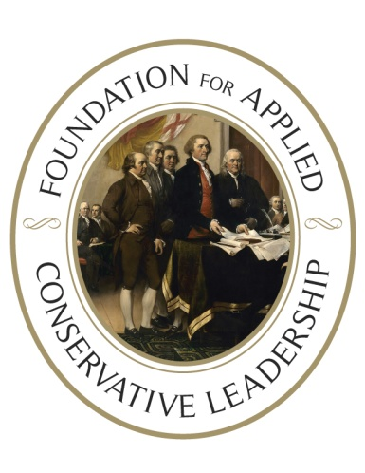

Unless you are politically feared, you

will never be politically respected.

**MULBERRY, FLORIDA**

**CAMPAIGN MANAGEMENT SCHOOL**

**Highland Ag Solutions Building**

**590 NW 3rd St, Mulberry, FL 33860**

**Saturday, October 4th/ 9am - 5:30pm**

You owe it to the principles you stand for to learn how to become the most effective activist you can be.

The Foundation’s Campaign Management School will help teach you the fundamentals needed to win elections for liberty.

**If you are ready to DO something** to take back power from the politicians and elites for “We The People,” **you NEED to attend this class.**

This intense one-day training covers:

* The REAL Nature of Politics.
* The core of every campaign, including the Lincoln 4 Step; building your campaign plans; an introduction to timeline budgeting.
* Advanced campaign communications, including using the Leesburg grid, framing issues, and targeting your communications.
* Basic fundraising calling, mail, email and events.
* How to set up (and tear down) your campaign.

Who should attend this Campaign Management School?

* First-time candidates (for any office)
* Elected officials who want to run better campaigns
* Volunteers, staff, and those who want to influence the public policy process

The Foundation’s Trainers aren’t pointed-headed intellectuals and policy wonks. Our schools are taught by people who have been putting these principles to work in the political trenches and have the scars and stories to show you how to use the tools, tactics and strategies we teach to win for liberty.   
  
Seating is limited. Registration is $60 ($30 for students) and includes lunch.

**Register online, today**, and join us in advancing real conservative leadership.

[**https://facl-training.org/schools/events/mulberry-fl-cms-04oct2025**](https://facl-training.org/schools/events/mulberry-fl-cms-04oct2025)

**For more information** on the Mulberry training,

email Tom Vail at [tom@tomvail.tv](mailto:tom@tomvail.tv) or call (352) 348-6527.

***For more information on hosting a FACL***

***training in your area, email Deb Hopper***

***at*** [***ddh@facltraining.org***](mailto:ddh@facltraining.org)

101 Washington Street  
Falmouth, VA 22405

[www.facltraining.org](http://www.facltraining.org)

*I told my sons that what they learned in the one-day training took me about 20 years to learn in the school of hard knocks – and most people never learn the things the Foundation teaches. FACL provides a foundation that saves people years of running on the political hamster wheel to nowhere.~ Matt T (WI)*

*If you think you have no control over our future - think again. Invest in this course, implement this model and WIN!  
~ Christopher Z (NY)*

*Without the Foundation, we would be like every other "group" out there -frustrated with educating our legislators and expecting them to do the right thing.  
  
In just over 2 years we've taken over our school board, township board, stopped corporate welfare tax breaks, disrupted state budget talks and forced roll call votes giving us a list of BAD politicians to expose!~ Dean K (PA)*