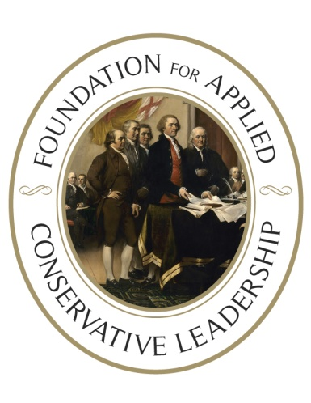

101 Washington Street  
Falmouth, VA 22405

[www.facltraining.org](http://www.facltraining.org)

Unless you are politically feared, you

will never be politically respected.

**AITKIN, MINNESOTA**

**POLITICAL LEADERSHIP SCHOOL**

**40 Club Convention Center**

**960 2nd St NW, Aitkin, MN 56431**

**Saturday, October 12th/ 9am - 5:30pm**

You owe it to the principles you stand for to learn how to become the most effective activist you can be.

The Foundation’s Political Leadership School will help you understand how the political process REALLY works, because when you understand how the political process works, you can make it work to advance the issues and causes you believe in that will restore America to its small-government, constitutional roots.

This intensive one-day training will teach you how to turn your conviction and passion into effective political action. **You will learn:**

* The REAL nature of politics and politicians and why just educating people alone won’t result in the political change you want;
* Why small groups of dedicated activists can and do win;
* Why you will never be politically respected until you are politically feared and how to build a group that is feared by politicians on the wrong side of your issue;
* You'll learn the greatest lie ever told in politics and how the political class uses that lie and your convictions against you;
* How to pick a good political fight;
* How to put together a legislative project, get a bill sponsor, and force a roll call vote despite opposition from the leadership;
* How to hold politicians accountable for their actions (or lack of action).

**In a nutshell, you’ll learn why you’ve been losing and how to start winning.**The Foundation’s Trainers aren’t pointed-headed intellectuals and policy wonks. Our schools are taught by people who have been putting these principles to work in the political trenches and have the scars and stories to show you how to use the tools, tactics and strategies we teach to win for liberty.

Seating is limited. Registration is $60 and includes lunch. Sign up early! Our **Early Bird rate** of $45 is good until three weeks prior to the training.

**Register online, today**, **or scan the QR code below** and join us in advancing real conservative leadership.

[**https://facl-training.org/schools/events/aitkin-mn-pls-12oct2024**](https://facl-training.org/schools/events/aitkin-mn-pls-12oct2024)

**For more information** on the Aitkin training, email Diane

Webb-Skillings at [mnpatriotgirl@proton.me](mailto:mnpatriotgirl@proton.me) or call

(218) 833-2124 or (218) 640-3276.

***If you’re interested in hosting a Political Leadership***

***School in your area, please email Deb Hopper***

***at ddh@facltraining.org.***

*I told my sons that what they learned in the one-day training took me about 20 years to learn in the school of hard knocks – and most people never learn the things the Foundation teaches. FACL provides a foundation that saves people years of running on the political hamster wheel to nowhere.~ Matt T (WI)*

*If you think you have no control over our future - think again. Invest in this course, implement this model and WIN!  
~ Christopher Z (NY)*

*Without the Foundation, we would be like every other "group" out there -frustrated with educating our legislators and expecting them to do the right thing.  
  
In just over 2 years we've taken over our school board, township board, stopped corporate welfare tax breaks, disrupted state budget talks and forced roll call votes giving us a list of BAD politicians to expose!~ Dean K (PA)*